Medical Statistics & Critical Reading

Background

Medical Literature
10 million medical articles on the shelves
4000 medical journals
Only 10% of the material has lasting scientific value

Types of Reading
Browsing reading - flicking through a publication & dipping into topics of interest
Targeted reading - turning to literature to answer a specific question for us
Critical Reading - gaining a comprehensive view of existing knowledge in a particular area.
evaluating the relevance of material that you are reading

What do the statistics mean? After this, read chapters 5 and 8 of “How to read a paper”

P-values - The probability that the result of the study could have occurred by chance.

Simply looking at “averages” can be misleading. I am testing a new BP drug. Every person taking it will respond slightly differently – some better than others. I test it in 3 people and the BP drops by an average of 10mmHg. Looks good. BUT – could it be that with this drug, BP actually goes up in most people and I just happened to have tested it on 3 people where the BP dropped a bit?

The more numbers I have, the better I can look at the spread (distribution pattern) of the results. The better I can judge the distribution pattern, the more sure I can be about chance effect. By convention, a p value of <5% (or <0.05) is defined as significant. The likelihood of your result being coincidence is less than 1 in 20 (5%) The bigger the change you see and the more people you test, the more believable your result is.

So I went back and I did my BP study on 100 people. I found an average drop of 8.9mmHg. I looked at the spread of the results and the p-value came out at 0.01 – ie 99% likely I was seeing a true drop and only a 1% chance that I happened to have tested it in a group of people who were non-representative “good-responders” – a significant result.

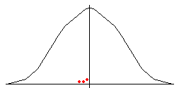
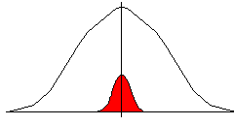

The main curve shows BP levels in the “normal” population. Perhaps the average change with my tablet is nothing but I happened
The red splodges are my 3 results. to have tested it in 3 people where there was a slight drop in BP?
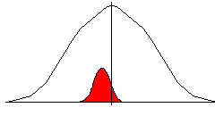
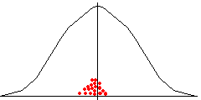

Do more tests and you start to get a better picture
Think about it – read a journal with 20 papers in it, quoting “significant” results with p= 0.05. One of those papers has recorded a fluke and has not really found anything “significant”.

Confidence Intervals – how confident should you be that your result is accurate?

Sounds similar to p-values but you need to think hard to spot the difference.
Statement of fact - my drug actually lowers BP by an average of 8.6mmHg.

If I picked another group of 100 people and tested my drug again, I would get a result that was slightly different from 8.9mmHg. If I did the study 10 times, I would probably get 10 different answers. Which one is true? Confidence interval calculations look at the data spread and give an indication as to where the “true” answer probably falls.

My BP study results may state: “the fall in BP was 8.9mmHg (p=0.01, CI –7.1 to –10.4).This means 1) - significant drop in BP averaging 8.9mmHg (only 1% likely to be a chance finding)
2) - 95% sure that the drug’s true BP lowering effect is between 7.1 and 10.4mmHg

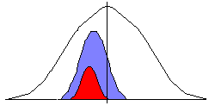
The blue curve shows the “true effect” of the drug when tested on a massive population.
The red curve is the spread of my results in my small sample population.
The confidence interval indicates how well I think I have matched up the 2 curves – big interval means I am not very confident, small interval means I am more sure that I am close to the “true” answer.

What if we get a “significant result” on p-values, but the confidence interval includes zero (or the point of no effect)? For instance p= 0.05, CI =1.4 to –5.6. What is being said is “In the people I picked to represent everyone, I am sure that the drug worked. But I did not look at enough people to be confident that these people really do represent the whole population. Please consider repeating the trial. then that is another way of saying it is possible that the drug achieved nothing.

If the confidence interval comes nowhere near zero (like CI –7.1 to –10.4), then we are pretty sure that our study population represents the whole population. We can be sure that our result is valid and that further trials are probably not needed.

Relative and Absolute Risks

Some studies measure changes in risk – like change in survival with a statin. Often the results are expressed in terms of changes in risk.

Absolute risk (AR) – statement of how often the “event” happened
Relative risk (RR) – risk of the event in one group “relative” to another group
Absolute risk reduction (ARR) – statement of how much the risk in one group is less than the risk in the other group
Relative risk reduction (RRR) – never bother with this one!

Example:
Annual stroke risk in high risk AF patients:
Aspirin – 11% stroke risk Warfarin – 6% stroke risk

AR of a stroke on warfarin is 6% (0.06) and the AR of a stroke on aspirin is 11% (0.11)
RR of a stroke on warfarin compared with aspirin is 54% (0.54) – 6/11
ARR from taking warfarin rather than aspirin is 5% (0.05) - AR reduced form 11% to 6%

RR numbers always look better than AR numbers! Saying warfarin is better than aspirin because the RR of a stroke is 54% lower sounds much better than warfarin gives an ARR of 5%.

Numbers Needed to Treat (NNT)

How many people do you need to “treat” with the study intervention to stop the study event from happening once? Remember that ARR is a “statement of the reduction in the rate of occurrence of an event”. NNT is simply the number of ARR’s needed to make 100%. In the example above, the ARR is 5%. This means 20 will be needed to make 100% - the NNT is 20. Therefore, treating 20 people with warfarin rather than aspirin, in the high risk groups, will prevent one stroke per year.

Forest Plots / Blobbograms After the tutorial, read “How to Read a Paper” Chapter 8

Metaanalysis means putting the results of several similar trials together and looking at the result. Thinking back to P-values, remember we said “The more numbers I have, the better I can look at the spread (distribution pattern) of the results”. This is what statisticians do with metaanalysis. One problem is that all the trials may have asked the question slightly differently. One may have presented data about death in the first 5 years after MI, another at death rates in the first 10 years etc. They go back to the individual study data and re-present the data so that the results are directly comparable. The big thing that changes when you pool results is confidence intervals. You are effectively repeating the trial several times and therefore it is logical that you should be more confident about where the “true answer” lies. This is what the Forest Plot (or blobbogram) represents.

Each trial is represented by one row on the plot. The box on each line represents the “result” of that trial. The length of the line drawn for that trial represents the confidence intervals for that trial. The very clever bit is the blob in the final row. This represents the new confidence intervals for the pooled results of all the trials.

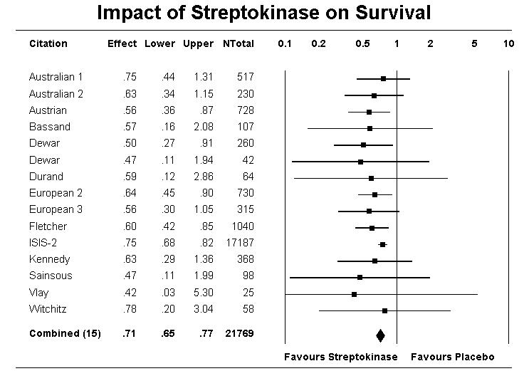

In this example, all of the trials showed improved survival with streptokinase. However, in a lot of the trials, the confidence interval crosses the line of no effect, making it hard to state with certainty that the trial definitely showed better survival. The final blob, however, unarguably lies on the “streptokinase works” side of the line. Put simply – no more trials needed.

READER Model for Critical Reading

The READER model was a model published in 1994 (BJGP 1994 44:83-85) by an academic GP looking for a reliable way to score the relevance and usefulness of scientific papers. Studies have shown that it is accurate, reproducible and improves confidence when appraising papers.
Score the paper in each of the four area then total the score.

Relevance
Not relevant to general practice 1
Allied to general practice 2
Only relevant to specialised general practice 3
Broadly relevant to all general practice 4
Relevant to me 5

Education
Would certainly not influence behaviour 1
Could possibly influence behaviour 2
Would cause reconsideration of behaviour 3
Would probably alter behaviour 4
Would definitely change behaviour 5

Applicability
Impossible in my practice 1
Fundamental changes needed 2
Perhaps possible 3
Could be done with reorganisation 4
I could do that tomorrow 5

Discrimination
Poor descriptive study 1
Moderately good descriptive study 2
Good descriptive study but methods not reproducible 3
Good descriptive study with sound methodology 4
Single blind study with attempts to control 5
Controlled single blind study 6
Double blind study with method problem 7
Double blind study with statistical deficiencies 8
Sound scientific paper with minor faults 9
Scientifically sound paper 10

Evaluation
Overall Score (Out of 25)

Reaction
Over 20 Classic paper that should make an immediate impact on practice. This article needs to be brought to a practice meeting and discussed.
15 –20 Average paper. Keep a record if it was interesting or of particular relevance to you, perhaps keep a note of the reference and abstract.
Under 15 Forget it!

